ML - Introduction

# Machine Learning

* You have probably written programs (code) in the past.

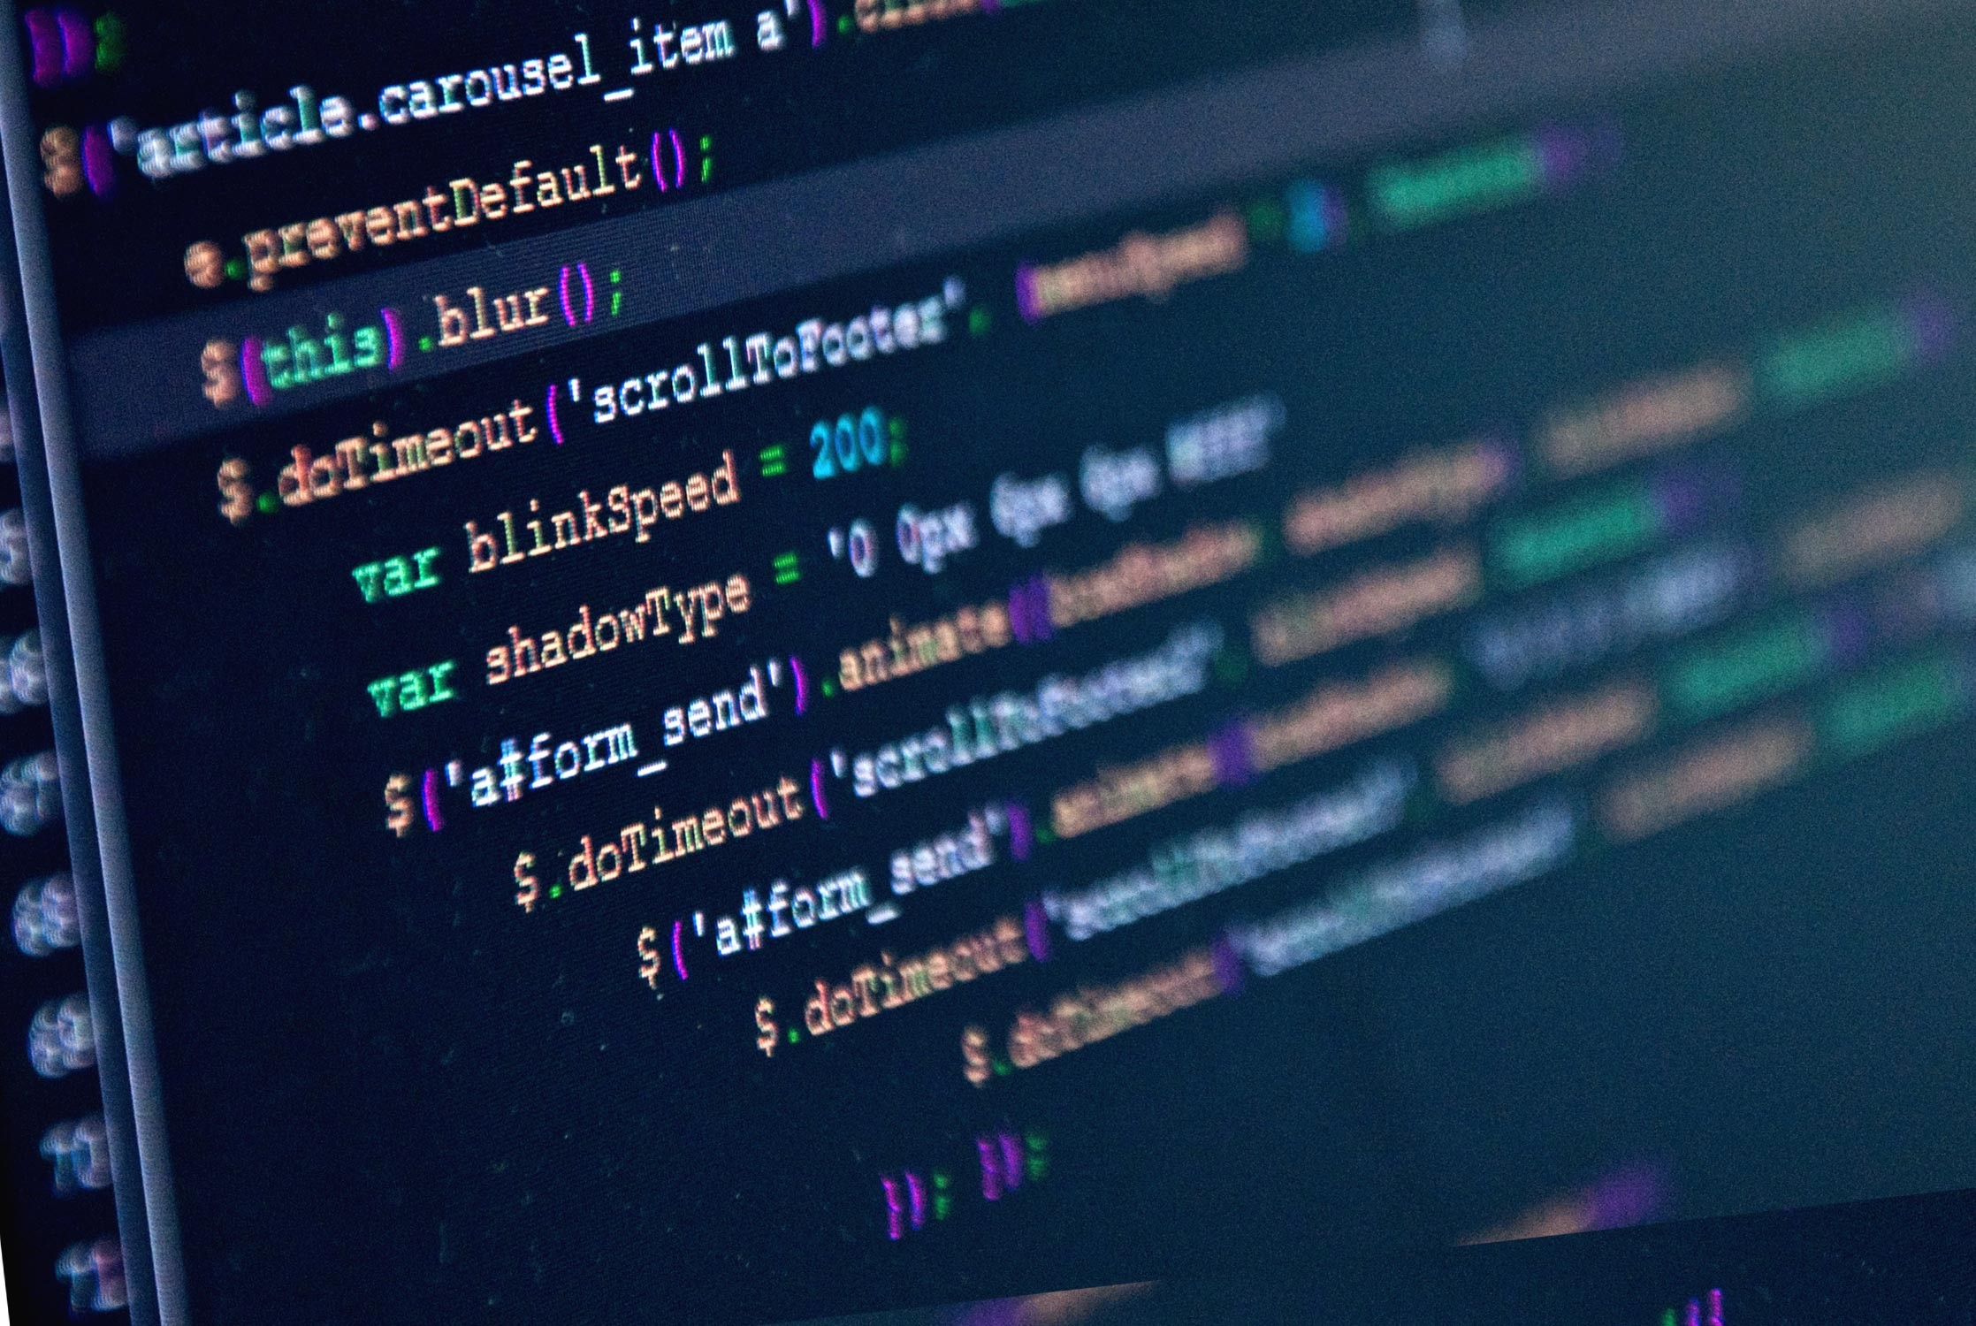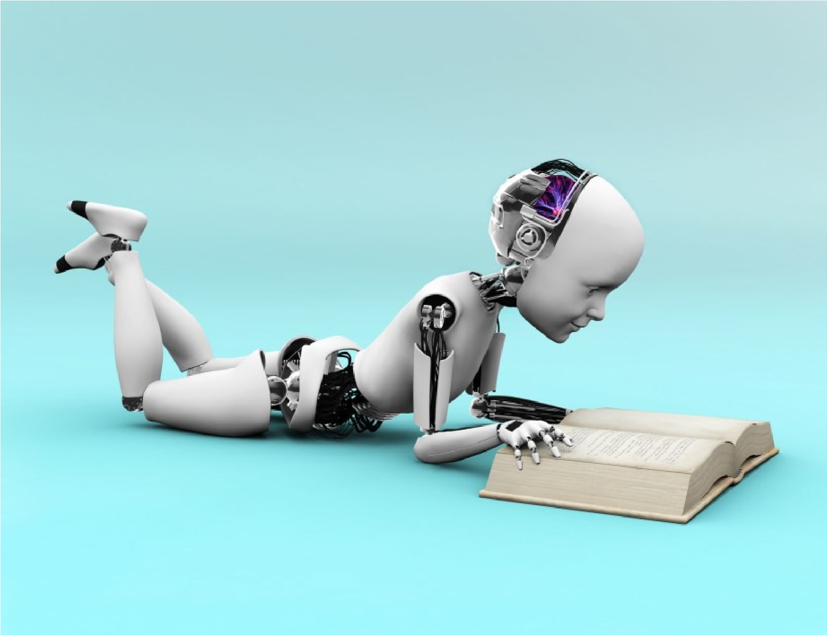

* You had to program every possible situation: Think of "if – then – else" statements.
* What if machines could learn by themselves from their environment or data.

# Machine Learning

* Machine learning is a method of data analysis that automates analytical model building.
* Using algorithms that iteratively learn from data, machine learning allows computers to find hidden insights without being explicitly programmed where to look.
* Sounds too good to be true? Well, it's already being widely used.

Let's look at some examples:

* Online Recommendation Systems
* System learns from your
  + purchase data

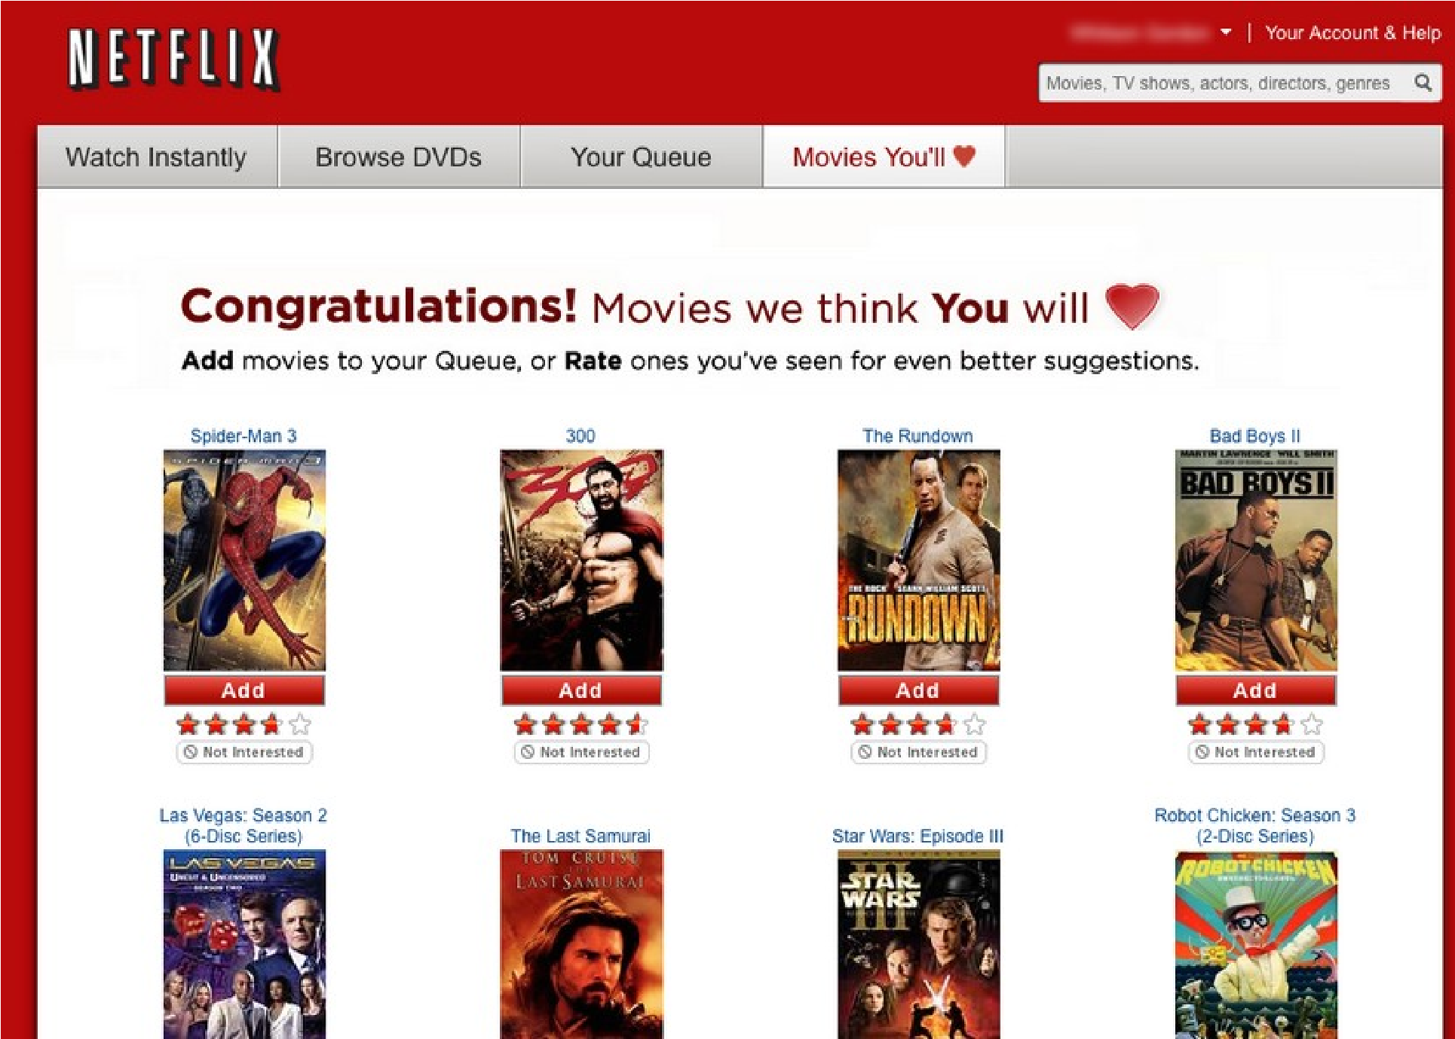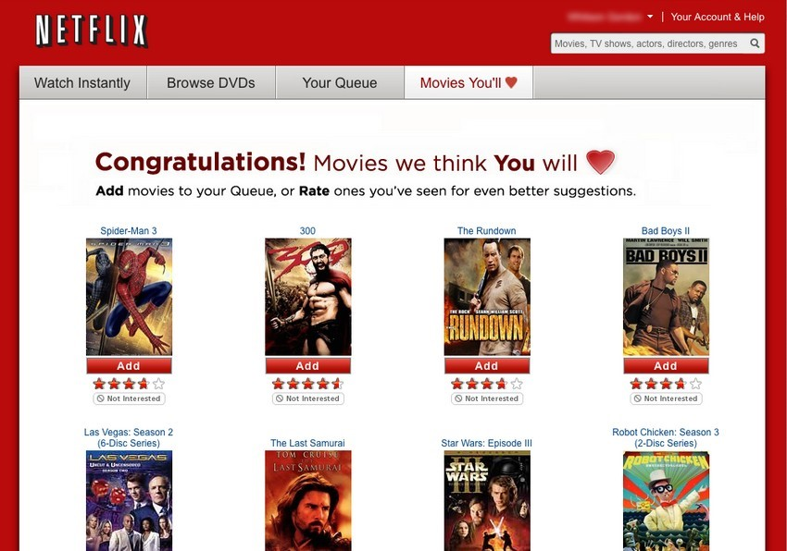

* + browsing history
  + viewing history
  + email data
* Spam Filtering
* 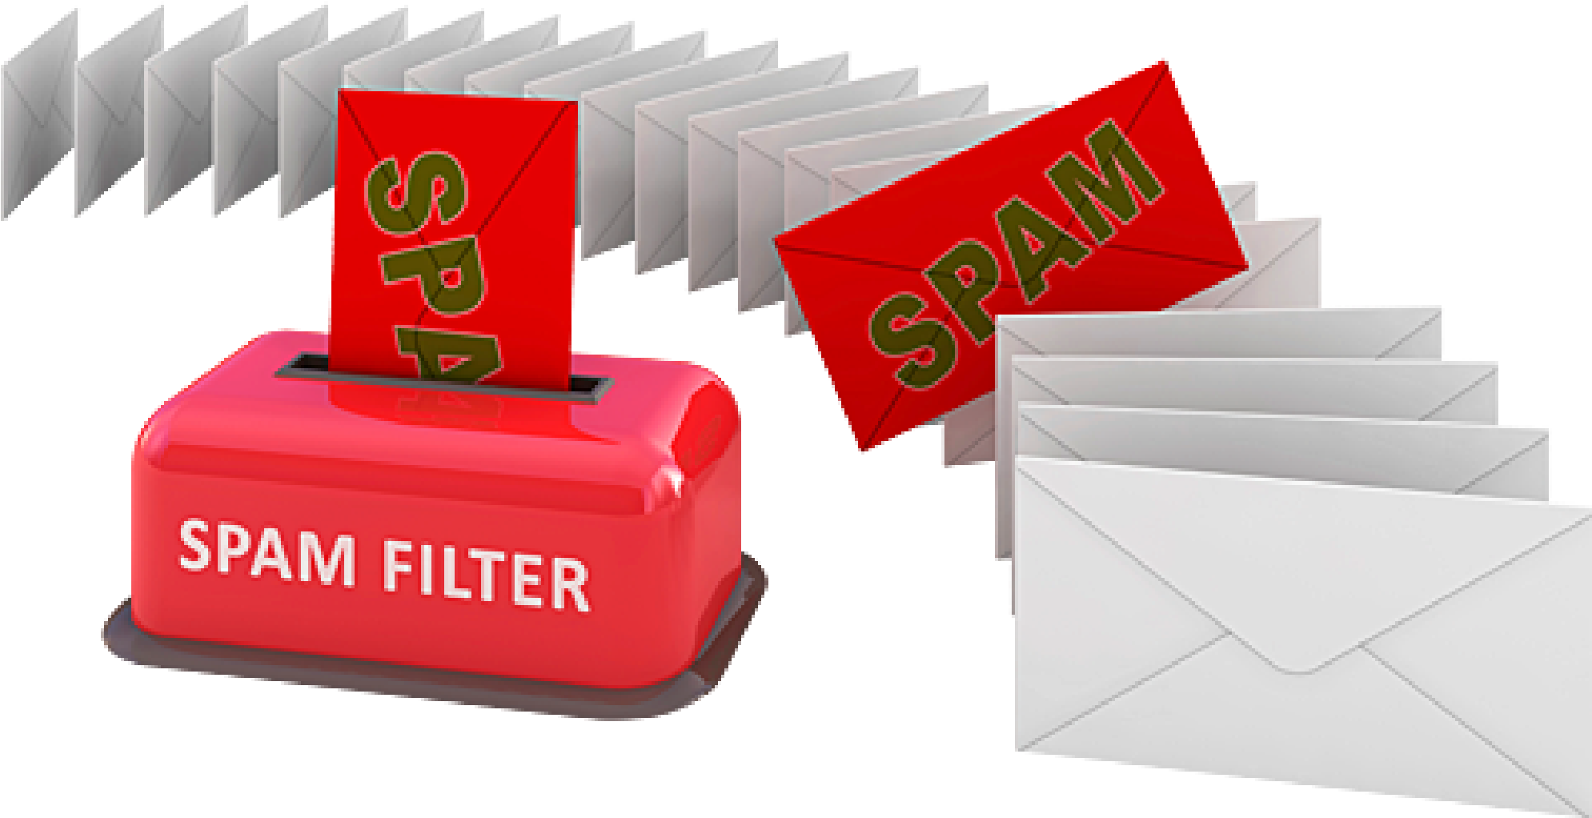Learning fromfeatures of spam emails to classify them as either SPAM or NOT SPAM.
* 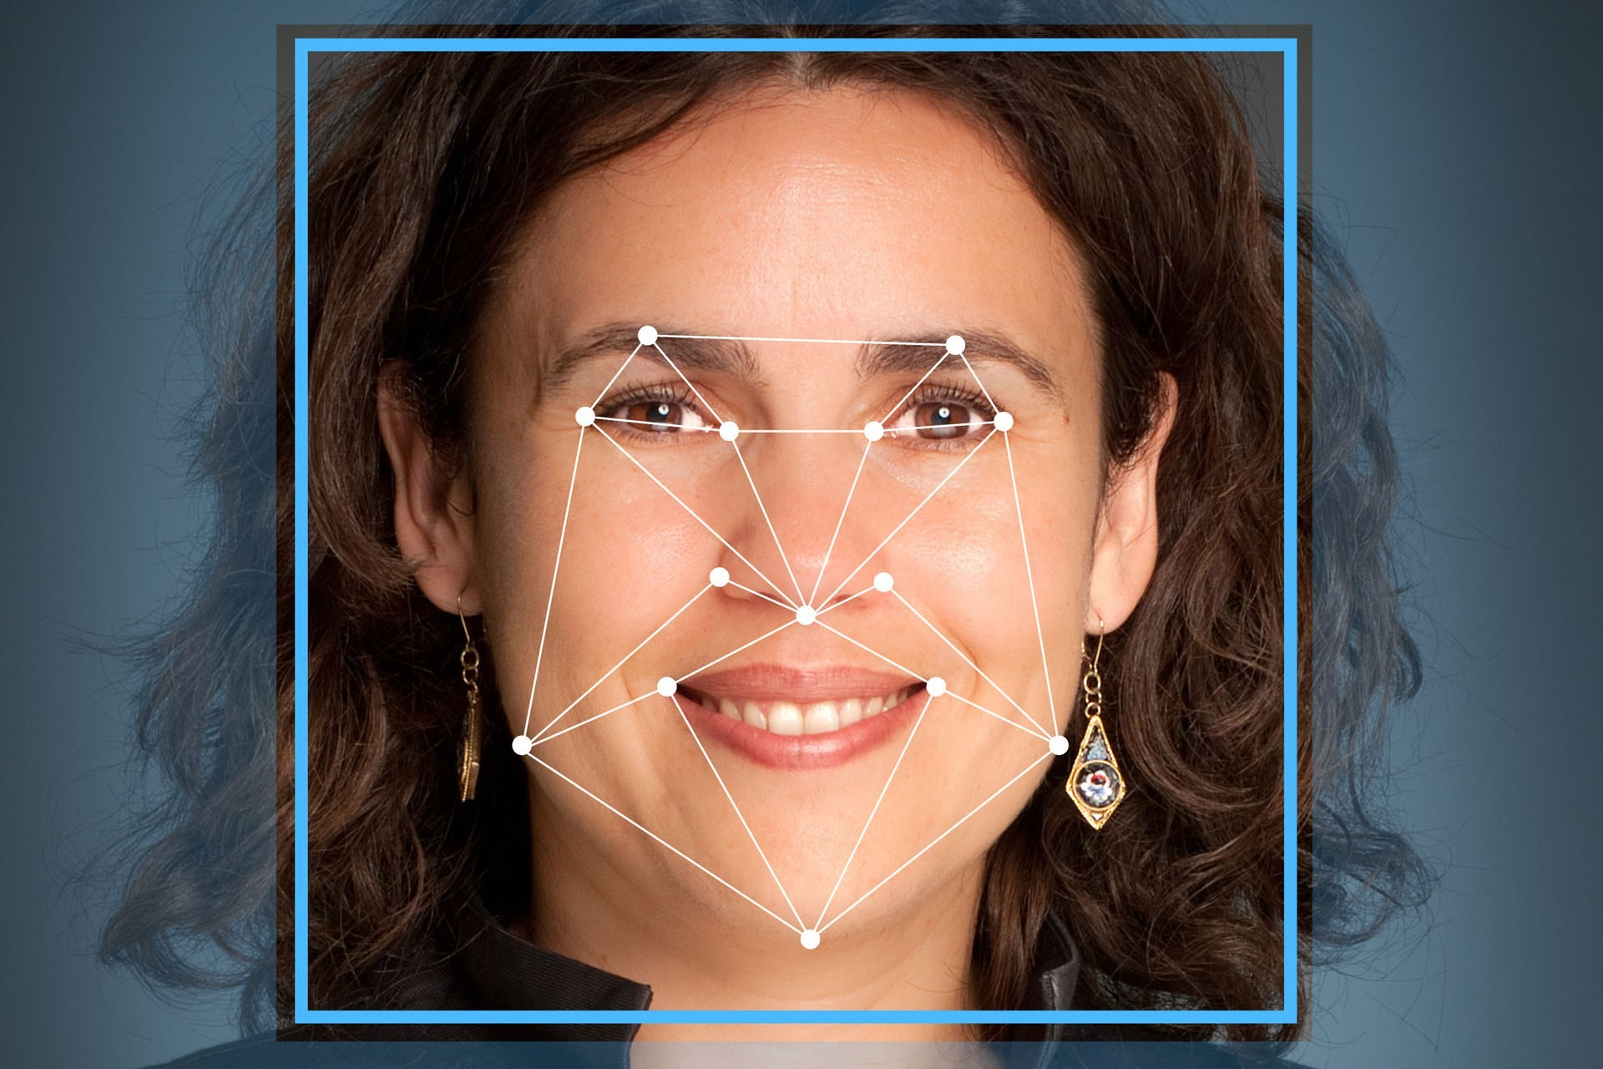Facial Image Detection

# Famous Machine Learning Examples

* Google's Deep Mind https://www.youtube.com/watch?v=TnUYcTuZJpM
* Google's Self Driving Car Project https://www.youtube.com/watch?v=TsaES--OTzM&t=5s
* Six Novel ML Applications https://www.forbes.com/sites/85broads/2014/01/06/six-novelmachine-learning-applications/#2cf1c42a1060

# Skills Needed

I want to be a machine learning scientist What do I need to do / learn?

* Strong math background
* Love data
* Programming skills
* Data analysis / pattern identification
* Ability to convey results to clients / users

## Math background

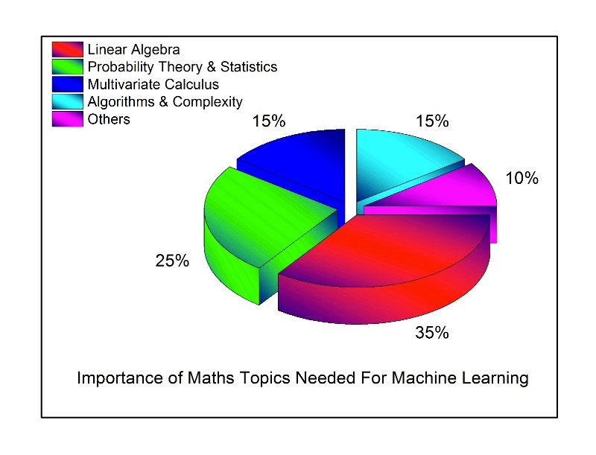

https://

towardsdatascience.com

/the

-

mathematics

-

of

-

machine

-

learning

-

894f046c568

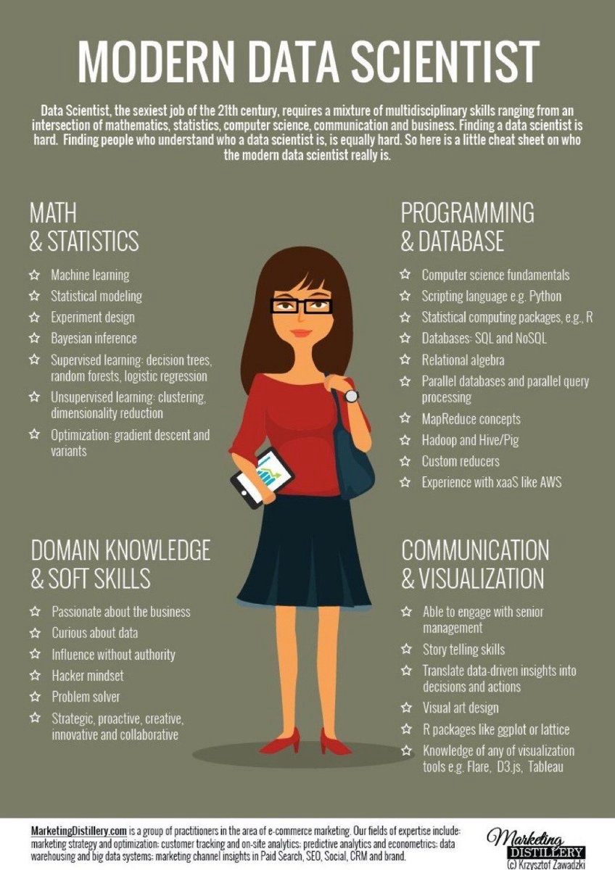Skills Summary

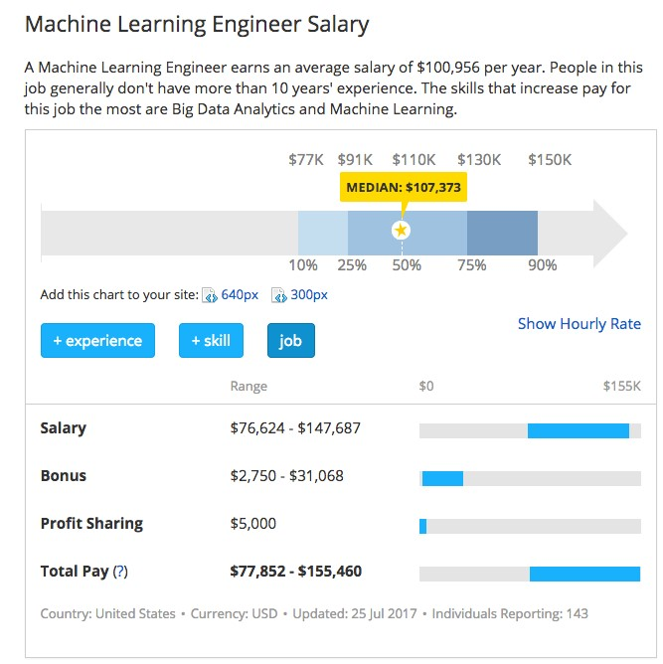Salary

Source: http://www.payscale.com/research/US/Job=Machine_Learning_Engineer/Salary

# Salary

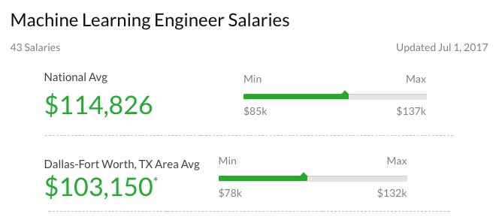

Source: https://www.glassdoor.com/Salaries/machine-learning-engineer-salary-SRCH_KO0,25.htm

# Opportunities

* All major companies are seeking skilled machine learning / data scientists.
* Too many to name J

# Let's get started

• What will this course teach me?

* Basics of ML
* Review of probability and statistics
* Foundation of learning
* Various learning instances (techniques)
* How to apply ML to real world datasets
* How to analyze data and results
* How to communicate those results

